Hands-On Lab
Lab Manual
Prepare the IDE JEE Eclipse

Contents
Prepare the IDE JEE Eclipse i
Lab 01: Configure the Eclipse for Web programming 3
Lab Objective 3
Exercise 1 – Configure JDK and Tomcat for Eclipse 3
Task 1 – Configure JDK for Eclipse 3
1. Start the eclipse 3
2. Open Preferences dialog 3
3. Select the JDK 3
Task 2 – Configure The server Runtime Environment 4
1. Open Preferences dialog 4
2. Add Server Runtime Environments 4
Exercise 2 – Write a Hello World JSP/Servlet application 4

Lab 01: Configure the Eclipse for Web programming
Estimated time to complete this lab: 10 minutes

Lab Objective
The objective of this lab is to introduce you to prepare the IDE JEE Eclipse for Web Programming.
- Configure the eclipse uses JDK instead of JRE.
- Configure the eclipse uses Tomcat 7.

Note: You have finished the lab “Install JDK and Tomcat”

Exercise 1 – Configure JDK and Tomcat for Eclipse

Task 1 – Configure JDK for Eclipse

  - Start the eclipse
By execute file “eclipse.exe” in the folder eclipse.
  - Open Preferences dialog
By going to menu “Window > Preferences”. Select node “Java > Installed JREs“. The installed JREs on the PC is used.
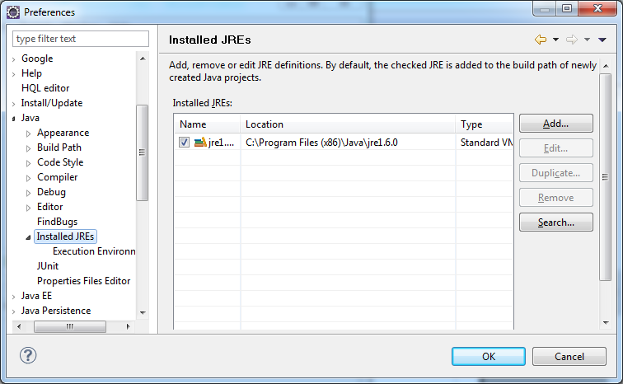
Click on “Add” button to add the JDK.
  - Select the JDK
From the dialog “Add JRE”, select item “Standard VM”. Click on Next button.
From the dialog “JRE Definition”, input the install JDK home folder (Ex: C:\Program Files\Java\jdk1.6.0). Then click on Finish button.
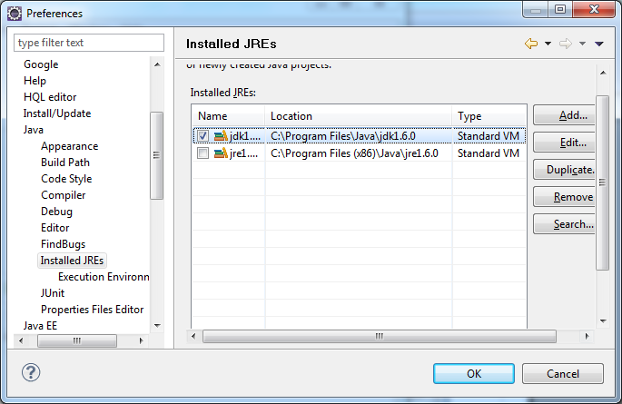
Check on the JDK. Then click on OK button to complete the task.
You can don’t install unnecessary features such as Java DB. Click on Next to continue.

Task 2 – Configure The server Runtime Environment

This exercise configures the Apache Tomcat 7 as a server runtime for the eclipse.

  - Open Preferences dialog
By going to menu “Window > Preferences”.
  - Add Server Runtime Environments
By select node “Server > Runtime Environments“.
Click on Add button. Select node “Apache > Apache Tomcat 7.0“. Click on Next button.
Input the Tomcat installation directory (ex: D:\jPackages\apache-tomcat-7.0.14). Click on Finish then OK button to complete the task.

Exercise 2 – Write a Hello World JSP/Servlet application

Try your self please!

Tips:
- Create a new Dynamic Web Project.
- Select target runtime: Apache Tomcat 7.0
- Right-click on the project to create a servlet
- Right-click on the folder “WebContent” of the project to create the index.jsp
- Execute the project by right-click on the project, select “Run as > Run on Server”. For the first running, select “Manually define a new server”, Tomcat 7.0 server. Then click on “Next”, “Finish” button to start the tomcat.

